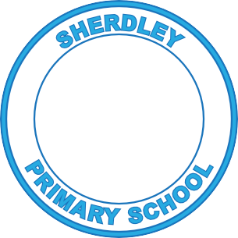
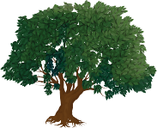
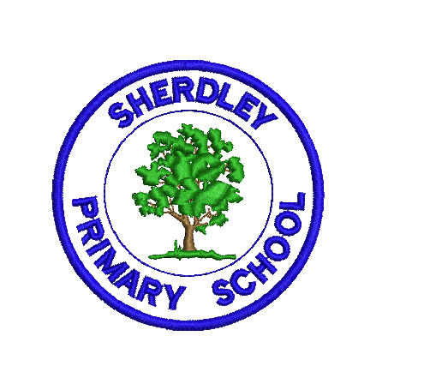
Sherdley Primary School 2022-23
English - Writing Curriculum Map

 | Autumn | Spring | Summer
Pre-School  (Talk for Writing) | Where’s Spot?  Pumpkin Soup  Stickman | Bear Hunt  Daisy and the Egg  Jasper and the Beanstalk | The Gruffalo  Whiffy Wilson  The Three Little Pigs
Write some or all of name.
Write some letters accurately.
Reception  (Talk for Writing) | The Owl Babies  Room on the Broom  Little Robin Red Breast  names, simple words/labels, captions and lists, simple sentence | Gingerbread Man  Little Hen Red  Handa’s Surprise  simple sentences/captions, instructions,  descriptions, labelling characters, pictures and story parts, poster, lists, simple recounts, life cycles (NF) | Mad about Minibeasts (Poetry)  Rainbow Fish  Giganotosaurus  recount, letters, information text, life cycles, poster, story ending
Punctuation & Grammar | Lower case letters | Lower case letters | Capital letters  Full stops
Year 1 | The Queen’s Hat-narrative  Toys from the Past- report (NF)  Firework Night- poetry | Beegu - narrative  Lost and Found-narrative  On Safari-travel journal (NF) | Pinocchio-narrative  Walk in the Woods-recount (NF)  The Train Ride- narrative
Punctuation & Grammar | Introduce capital letters . ? and !  Forming sentences  Leave spaces between words  Capital letters for names | Joining words with ‘and’  Capital letters for names and pronoun I | Joining words and clauses with ‘and’  Capital letters for names and pronoun I
Year 2 | The owl who was afraid of the dark- narrative  How to make a bird feeder – instructions (NF)  Hibernation- non-chronological report (NF) | The Great Fire of London- diary (NF)  The Crow’s Tale – narrative (fable)  This is how we do it – letter | George and the Dragon - narrative  Little Red Reading Hood- narrative  Desk Diddler - poetry
Punctuation & Grammar | Co-ordinating conjunctions (or, and, but)  Subordinating conjunctions (when, if, that, because)  Expanded noun phrases  Statements/ questions/ exclamations/ commands  Present and past tense  Capital letters/ full stops/ question and exclamation marks | Make adjectives using suffixes -ful -less -er -est  Make adverbs by using -ly  Expanded noun phrases  Statements/ questions/ exclamations/ commands  Commas in lists  Apostrophes | Make nouns using suffixes -ness -er  Expanded noun phrases  Statements/ questions/ exclamations/ commands  Apostrophes
Year 3 | How to Wash a Woolly Mammoth (Transition Unit) – Instructions (NF)  Stone Age Boy – Narrative  Skara Brae - Holiday Brochure (NF) | Autumn is Here-Poetry  The True Story of the 3 Little Pigs - Narrative  Flood-Persuasive letter to DIY SOS | How A Robot Dog Works  (Mr Hublot animation) - Explanation (NF)  Wolves in the Walls - Narrative  The Journal of Iliona - Diary (NF)
Punctuation & Grammar | Imperative verbs  Subordinating and coordinating conjunctions.  Prepositions and prepositional phrases.  Adjectives  Subheadings and headings.  Past/present tense  Adverbial phrases  Clauses and phrases  Expanded noun phrases  a/an | Inverted commas  Paragraphs  Past/present tense  Precise nouns  Present perfect tense | Paragraphs  Subheadings  Conjunctions  Relative clauses  Complex sentences  Adverbs
Year 4 | The Blue Umbrella – Narrative  Digestion – Explanation (NF)  The Plague Village – Playscript (NF) | The Lost Thing – Fantasy  The Creature – Newspaper report (NF)  Still I Rise – Poetry | Theseus and the Minotaur – Narrative Myths and Legends (History link)  The Iron Man – Narrative  Holiday Brochure – Persuasive Writing (NF)
Punctuation & Grammar | Expanded noun phrases  Fronted adverbial  Inverted commas  Appropriate choice of pronoun or noun for cohesion. | Standard English forms  Apostrophes to mark plural possession Grammatical difference between plural and possessive -s | Use of paragraphs to organize ideas, consolidation of previously taught skills.
Year 5 | The Nowhere Emporium - narrative  The Fantastic Flying Books of Mr Morris Lessmore – narrative  Mars Transmission -Film unit - journal (NF) | The Highway man – poem  Gorilla - narrative  Plastic pollution - speech (NF) | Malfeasance - poem  Cloud Tea Monkeys – narrative  Emperor Penguins - non chronological report (NF)
Punctuation & Grammar | Relative clause  Brackets, dashes or commas to indicate parenthesis  Adverbials to link across paragraphs | Adverbs  Modal verbs  Use commas to clarify meaning or avoid ambiguity | Modal verbs  Use commas to clarify meaning or avoid ambiguity  Adverbials to link across paragraphs
Year 6 | Endangered Species: Non-Chronological report (NF)  Warhorse: Diary (NF)  Alma: Narrative  Anti-bullying week: Letter (NF) | The piano: Poem  Lost Words: Non-Chronological report  Poem (NF)  A cloudy lesson: Instructions (NF) | Francis: Narrative  The Amazon: Information text (NF)  The Explorer: Survival Guide (NF)  New School: Double page spread (NF)
Punctuation & Grammar | Semi-colons, colons or dashes to mark boundaries between independent clauses  Colons and semi-colons when writing lists  Punctuating bullet points  Cohesion across paragraphs with different devices  Formal/informal language  Synonyms and antonyms | Semi-colons, colons or dashes to mark boundaries between independent clauses  Colons and semi-colons when writing lists  Punctuating bullet points  Cohesion across paragraphs with different devices  Formal/informal language  Synonyms and antonyms | Semi-colons, colons or dashes to mark boundaries between independent clauses  Colons and semi-colons when writing lists  Cohesion across paragraphs with different devices  Using the subjunctive form  Synonyms and antonyms

